Risk Card Game

**Product’s Description**

The product team has designed a simple turn-based decision-making game with the following description. For each game cycle, the player starts with an initial balance and has to spend a small amount from his balance to initiate a game. Then the player goes through consequent rounds where he is presented with four hidden cards. Only three are winning cards, so the player is given the option to either take the risk and reveal a card or forfeit. If the player chooses to reveal a card and wins, the card’s score is multiplied by the round number and added to the winning pool for that game cycle. If the player reveals the losing card, the winning pool is discarded and the game cycle ends. On the other hand, if the player chooses to forfeit, the winning pool is added to his balance and the game cycle ends. Winning cards have a fixed score value and are stacked in a deck, from which 3 random cards are drawn each round and are shuffled back in after the round ends. The winning pool should be cleared at the start of a game cycle.

**Software Architecture**

The flowchart of the product’s logic is shown below:

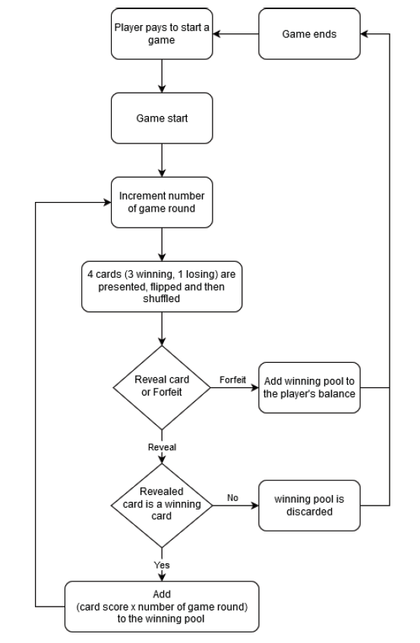

**Development Analysis**

Home screen script

Main app scritp

**Execution Instructions**

asd